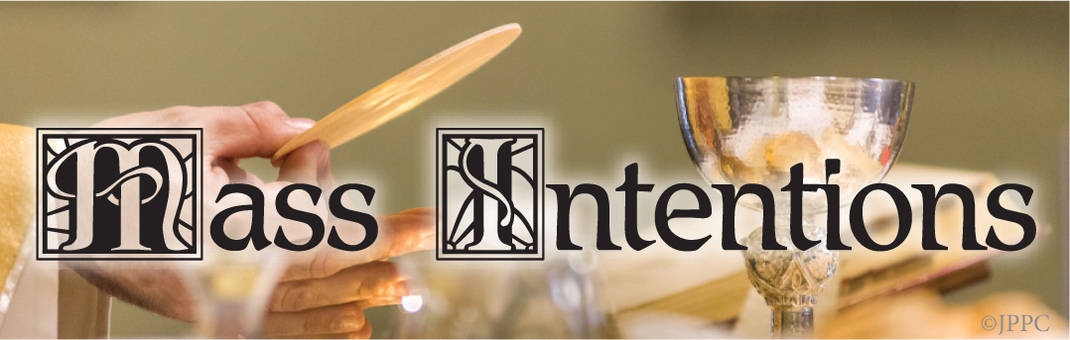

Monday June 9, 2025
6:30 Frank Tiziano req. by Denise Herens

8:00 Joan Kelly req. by Anthony & Pat Melfi

Tuesday June 10, 2025
6:30 Carmen Guarino req. by John Mirkil
8:00 Dolores Reilly req. by Family

Wednesday June 11, 2025
6:30 Bridget Higgins req. by Mom, Dad, John
8:00 Carolyn McCann req. by Tom & Susan Wilson

Thursday June 12, 2025
6:30 Carolyn McCann req. by Vicky & Brian Reilly
8:00 Mary Dahms req. by Juliano Family
9:30 Dorothy Dillon req. by Mike & Sharon Fischer

Friday June 13, 2025
6:30 Toni Bird req. by Antoinette Coppola
8:00 Joan Donahue req. by Fran & Ed Kubala

Saturday June 14, 2025
8:00 Dorothy/Anthony Hewitt req. by Friends
5:00PM Robert Duggan req. by Family

Sunday June 15, 2025
6:30 Joseph Adams req. by Kathy & Jerry Smith
8:00 Bob McHale req. by Family
10:00 Marilyn Della Pia req. by Mother
12:00 Robert D. Taylor req. by Ellen Taylor

LITURGY SCHEDULE FOR JUNE 15, 2025
Mass Communion Lectors
5:00PM H. Conway S. Donohue
M. Derbyshire

6:30AM S. Brown K. McNabb
8:00AM J. Robbins J. Teson

10:00AM N. Burnosky P. Cummings
J. Hopkins D. Makowiecki

12:00PM P. Cargan J. Guiffre
M. Hall

PRIEST MASS SCHEDULE FOR
SUNDAY, JUNE 15, 2025
5:00M Fr. John
6:30AM Fr. John
8:00AM Fr. Kirk
10:00AM Fr. Kirk
12:00PM Fr. Town

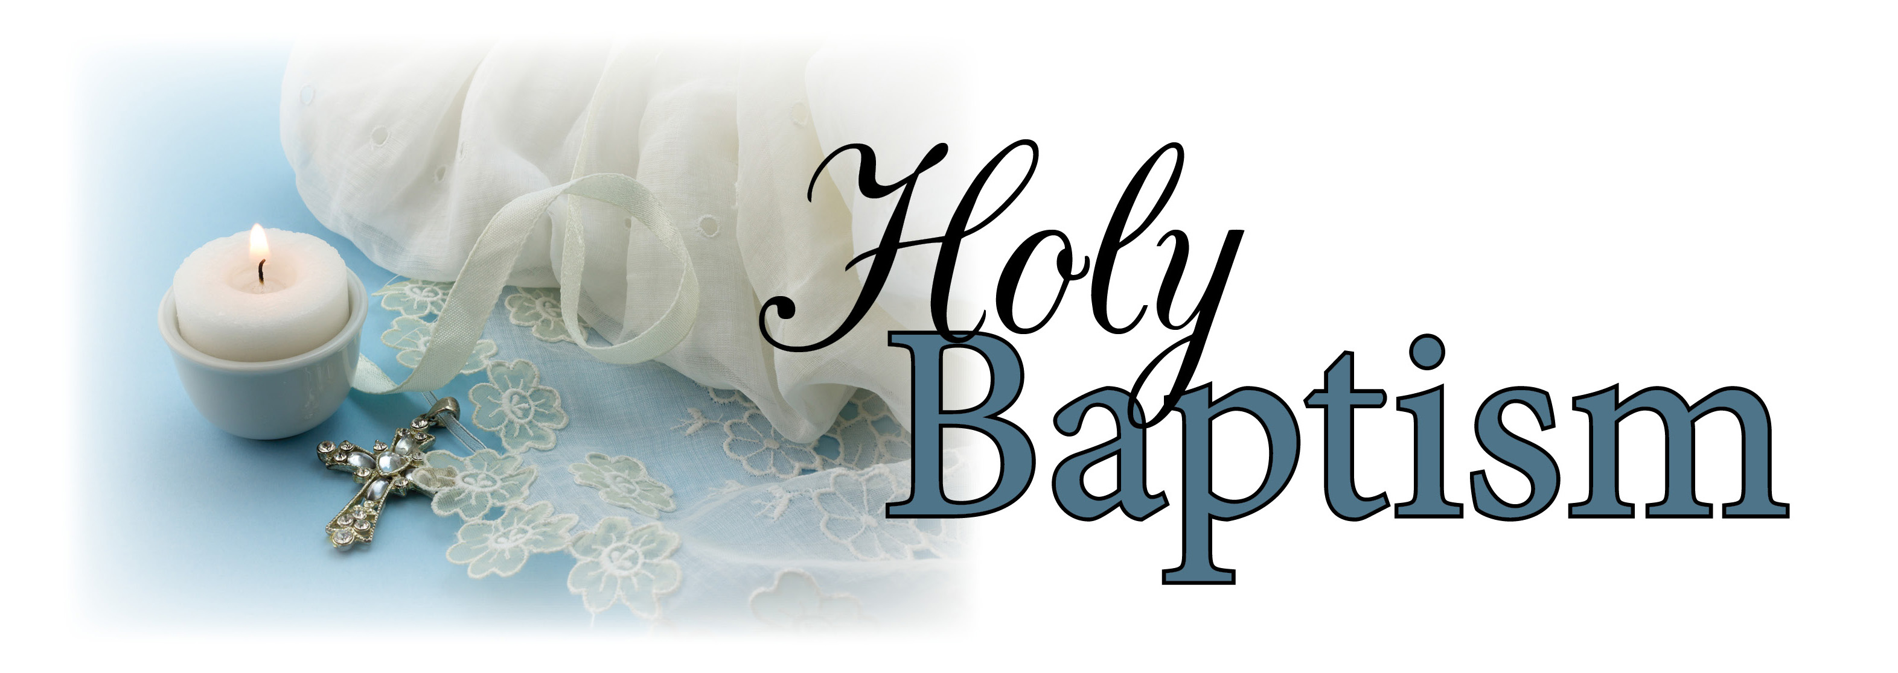
On Sunday, June 1, 2025, two girls received the sacraments of Baptism by which they were incorporated into the Body of Christ:

Josephine Sage and Scotlyn June – daughters of M/M Michael Lehman

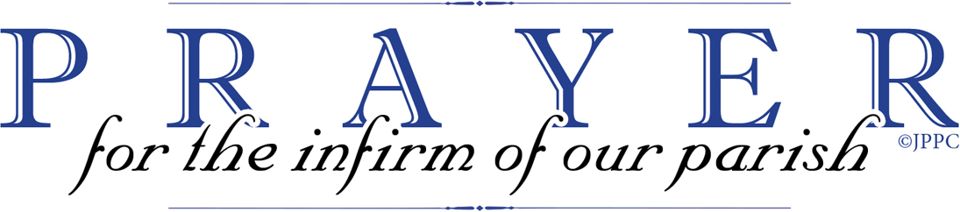

All sick parishioners, their relatives, and friends:

Mark Dezii - friend of Christine Frake

All deceased parishioners, their relatives, and friend:

Margaret Shaw – parishioner
John Dillon – parishioner
Raymond McNulty – husband of Dolores McNulty
Betty Lowery – sister of Janice Conville
Danielle Kornhaas – friend of Kerri Benner
Dr. Ronald Bevilacqua – relative of James and Judy Perry
Elizabeth Duggan – mother of Kathleen Duggan

For those in the armed forces: Jack Coffey-Air Force; Jacob Gizzi-Marines; Joseph Pitts-Air Force; Brendan Vizza-Marines; Andrew Morrison, Marine Corp; Eric Charles Taylor-Navy; Emma Marks-Navy; Ryan Sylvester-Air Force; Kyle Higgins-Army; Justin T. Erbrick-Army; Sean Conroy-Navy; Joseph Erbrick, III-Marines; Joseph Costick-Coast Guard; Christopher Smith-Navy; Alex McAneney-Air Force; Brian McGinty-Marines; Dan O’Brien-Air Force; Ashley O’Brien-Air Force; Daniel Patty-Navy; Michael Sheppard-Air Force; Hoku Teson-Army; John McFillin-Navy; Trevor O’Malley-Army; Daniel Taylor-Air Force; Stephen Winther-Marines; Bobby Winther-Navy; Amanda Smith-Navy; Joseph Patty-Army; Christian Curtis-Marines; Thomas Campbell-Marines

Divine Mercy Prayers are on the third Sunday of each Month after the 10 AM Mass. All are welcome.

Hospital Visits - If you are in the hospital and would like a visit from a priest, please call the rectory office at 215-637-7515. Due to HIPPA laws we are unable to get information from the hospital - we must hear directly from the patient/family.

FAMILY MATTERS
First be yourself, what you want your children to be!...as for me and my household, we will serve the Lord. Pope Francis says, “Say thank you, I love and I am sorry often.”

Page 1/203

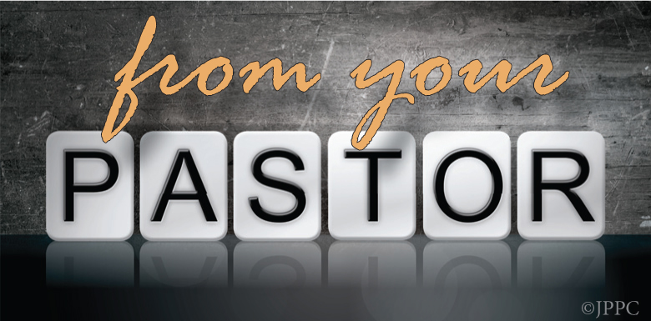

CONGRATULATIONS to REV. EDWARD TOWN on his ordination of May 17th. Rev. Town will be at Our Lady of Calvary to celebrate mass here on Sunday, June 15, 2025 at 12:00PM. Please join us for Mass and a brunch afterwards. If you plan to attend the brunch, an RSVP is needed, please sign the sheet in the back of church or call the rectory.

PETER’S PENCE – is the second collection on the weekend of June 14 /15, 2025. This collection is a gesture of solidarity through which every member of the faithful can participate in the activity of the Pope as Pastor of the universal Church. The offerings to the Holy Father through the Peter’s Pence Collection are destined to Church needs, to humanitarian initiatives and social promotion projects, as well as to the support of the Holy See. For more information, go to https://www.obolodisanpietro.va/en.html

TEMPORARY ENVELOPES – Please remember before placing a temporary envelope in the Offertory basket at Mass to write your name and address on the front of the envelope. Temporary envelopes are located right inside the front doors of the Church. Thank you for your continued support of Our Lady of Calvary Parish.

CALVARY SENIORS meet every Tuesday at Regina Coeli Hall (across from Torresdale train station), 9617 James Street. Doors open at 9:30 and the meeting starts at 10:30.

FATIMA HOLY HOUR FOR WORLD PEACE is sponsoring a Fatima Holy Hour for World Peace on Friday, Jun e 13 at Maternity of the Blessed Virgin Mary Church, 9220 Old Bustleton Avenue at 7:00PM. All are welcome to participate in the devotions to Our Lady of Fatima. Devotions include procession with Fatima statue, rosary and benediction.

Retrouvaille: Rediscover the Love in your Marriage – Tens of thousands of couples have healed their marriages through Retrouvaille. If you know anyone who could benefit from this program, please pass this on. Couples learn to build communication skills and to increase intimacy. It provides help for marriage problems, difficulties or crises. The next program will be held August 1-3, 2025 at the Family Life center in Malvern, PA. For more information, or to register, visit www.HelpOurMarriage.org or call 215-766-3944. All inquiries are strictly confidential.

CALLING ALL CRAFTERS AND VENDORS! Saint Thomas Aquinas Parish is now accepting applications for our 2025 Christmas Craft and Vendor Show, taking place on Saturday, November 1st and Sunday, November 2, 2025. $40.00 fee covers the weekend! For more information, please contact Cindy Kay-Salmon by text at 267-566-2477.

2026 MASS BOOK OPENING
The official opening of the 2026 Mass Book is June 16, 2025 – we are accepting only two (2) Masses per family until then. Please enclose your stipend of $10.00 per Mass with the name of your intention and preferred date – include a telephone number where you can be reached in the event of a conflict with your date selection. Mass dedications will be accepted on a first-come, first-serve basis. Please keep in mind that you are requesting the holy sacrifice of the Mass, which is something to be “shared” by all.

Name of Intention Date/Time

1- _______________________________________________

2-________________________________________________

Requested by ___________________________________

Phone #__________________________________________

Al Anon meeting at 7:00PM on Sundays (in person) in the lower church meeting room.

Page 2/203

Can 1 million frozen embryos be placed for
adoption? (Part 1 of 2)
By Katie Yoder Our Sunday Visitor

Katie McMahon and her husband realized the gravity of using in vitro fertilization, or IVF, to conceive when, years later, they needed to make a decision about their final four embryonic children frozen in time by cryopreservation.

“We really had kind of come to see the disorder with IVF and didn’t want to pursue IVF again, but it became apparent that these were indeed our children,” she told OSV News. “The dilemma became ‘Are we going to choose embryo adoption?’ or ‘Are we going to try to gestate them ourselves?’”

Today, McMahon helps other women navigate questions like these as the co-founder of
Shiloh IVF Ministry, a ministry that offers hope and healing those impacted by IVF. Her story is one of many: Estimates suggest more than 1 million frozen embryos exist in the United States alone. They are the result of IVF, a procedure where embryos are created in a laboratory and then transferred to a woman’s womb. More embryos are created than transferred – one of the many reasons why the Catholic Church opposes IVF – and many are stored away in a frozen state. Each of these embryonic children is a human person with the same dignity and essential rights (including the right to life) as a born child or any other human being, according to church teaching.

McMahon and other Catholic experts, including a bioethicist and the founder of a burial ministry for deceased embryonic children, spoke with OSV News about the future of these unborn children and the possibility of placing them for adoption in light of church teaching. While embryonic children must be treated as persons, the church distinguishes regular adoption, or adoption after birth, from embryo adoption.

“Prenatal or embryo adoption involves the adoptive mother having the abandoned embryo transferred to her womb in the same procedure as couples using in vitro fertilization attempt to achieve pregnancy.” said Joseph Meaney, past president and senior fellow of The National Catholic Bioethics Center, or NCBC. “The main question that has yet to be fully resolved by the Church is if it is morally licit to become pregnant with and gestate a child who is from outside the marital union?”

Church teaching

Catholic bioethicists largely cite two Vatican documents on the topic of embryo adoption: “Donum Vitae” (“The Gift of Life”) from 1987 and Dignitas Personae” (Dignity of a Person”) from 2008. Both come from the Congregation (now Dicastery) for the Doctrine of the Faith.
“Dignitas Personae” directly addresses the question of what to do with the “large number of frozen embryos already in existence,” while commenting on the “grave injustice.”

The document first condemns proposals “to use these embryos for research or for the treatment of disease” or to “thaw such embryos without reactivating them and use them for research.” It also rejects the proposal that they “could be put at the disposal of infertile couples as a treatment for infertility.”

The document moves next to adoption.
“It has also been proposed, solely in order to allow human beings to be born who are otherwise condemned to destruction, that there could be a form of ‘prenatal adoption,’” it reads. “This proposal, praiseworthy with regard to the intention of respecting and defending human li e, presents however various problems.”

It adds: “All things considered, it needs to be recognized that the thousands of abandoned embryos represent a situation of injustice which in fact cannot be resolved.”

“Dognitas Personae” goes on to cite St. John Paul II, who made an appeal in 1996 “That the production of human embryos be halted, taking into account that there seems to be no morally licit solution regarding the human destiny of the…’frozen’ embryos which are and remain the subjects of essential rights and should therefore be protected by law as human persons.”
https://www.osvnews.com/can-1-million-frozen-embryos-be-placed-for-adoption/

Page 3/203

