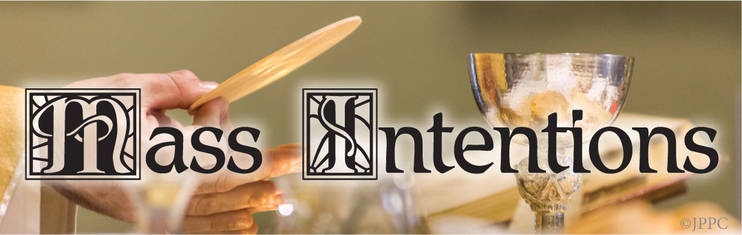

Monday May 5, 2025
6:30 Joanne Caruso req. by Fred & Monica Bloesch
8:00 Fr. Michael Vogt req. by Marge Azzolina

Tuesday May 6, 2025
6:30 Alisa Devlin req. by Denis Herens
8:00 Elisa Tyson req. by Walt Podsiedlak

Wednesday May 7, 2025
6:30 Thomas Elmer req. by Mother
8:00 Mary & James McFadden req. by Benner Family

Thursday May 8, 2025
6:30 Dr. Alisa Devlin req. by Joan Whoriskey
8:00 Hugh & Margaret Bonner req. by Family

Friday May 9, 2025
6:30 Theodore Tarasiweicz req. by Daley Family
8:00 Edward Murray req. by Terri Cardile

Saturday May 10, 2025
8:00 Kathy Charlesworth req. by M/M R. Gilbert
5:00PM Joe Trojak req. by Wife Jean

Sunday May 11, 2025
6:30 Bridget Higgins req. by Mom, Dad, John
8:00 Wadyslaw Cieslik req. by Family
10:00 Marilyn Della Pia req. by Mother
12:00 Dec’d Mem of Marasheski Fam req. by TesonFam

LITURGY SCHEDULE FOR MAY 11, 2025
Mass Communion Lectors
5:00PM H. Conway D. Haggerty
M. Derbyshire

6:30AM L. Konopka K. McNabb
8:00AM J. Klady R. Johnson
A. Lozada

10:00AM J. Hopkins C. Comly
P. Kolman J. Lynch

12:00PM B. Richmond J. Spear
D. Bores

PRIEST MASS SCHEDULE FOR
SUNDAY, MAY 11, 2025
5:00M Fr. John
6:30AM Fr. Kirk
8:00AM Fr. Kirk
10:00AM Fr. John
12:00PM Fr. John


On Sunday, April 27, 2025, one girl and three boys received the sacrament of Baptism by which they were incorporated into the Body of Christ:
Savannah Rose Jackson – daughter of M/M Matthew Jackson
Kieran Thomas O’Driscoll – son of M/M Ryan O’Driscoll
Brayden M. Santiago – son of Anthony Santiago and Sara Varley
Grady Harold Myers – son of M/M Philip Myers

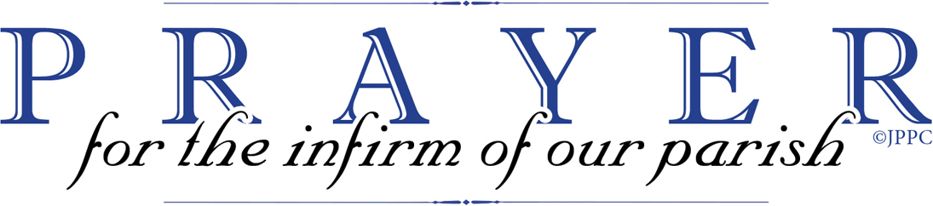

All sick parishioners, their relatives, and friends:
Mark & Mary Williams - parishioners

All deceased parishioners, their relatives, and friend:
Bill Newhart - cousin of Peg Cummings

For those in the armed forces: Jack Coffey-Air Force; Jacob Gizzi-Marines; Joseph Pitts-Air Force; Brendan Vizza-Marines; Andrew Morrison, Marine Corp; Eric Charles Taylor-Navy; Emma Marks-Navy; Ryan Sylvester-Air Force; Kyle Higgins-Army; Justin T. Erbrick-Army; Sean Conroy-Navy; Joseph Erbrick, III-Marines; Joseph Costick-Coast Guard; Christopher Smith-Navy; Alex McAneney-Air Force; Brian McGinty-Marines; Dan O’Brien-Air Force; Ashley O’Brien-Air Force; Daniel Patty-Navy; Michael Sheppard-Air Force; Hoku Teson-Army; John McFillin-Navy; Trevor O’Malley-Army; Daniel Taylor-Air Force; Stephen Winther-Marines; Bobby Winther-Navy; Amanda Smith-Navy; Joseph Patty-Army; Christian Curtis-Marines; Thomas Campbell-Marines

Divine Mercy Prayers are on the third Sunday of each Month after the 10 AM Mass. All are welcome.

Hospital Visits - If you are in the hospital and would like a visit from a priest, please call the rectory office at 215-637-7515. Due to HIPPA laws we are unable to get information from the hospital - we must hear directly from the patient/family.

Page 1/203

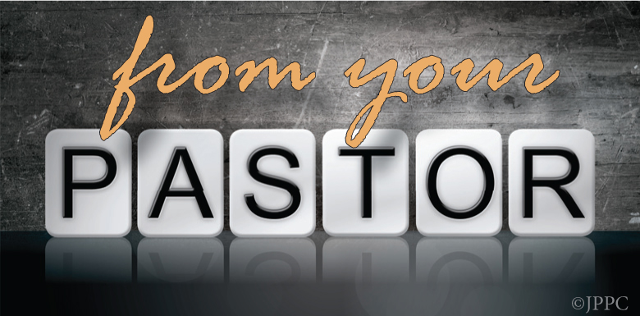

CONGRATULATIONS to our Students and PREP Students who made their First Holy Communion on Saturday, May 26. May God bless them and their families.

BEREAVEMENT MINISTRY began on Tuesday, April 29 and will continue until Tuesday, June 10. Sessions begin at 7:00PM in the lower church meeting room. No sign-up is required. All are welcome to attend.

MANNA BAGS will be distributed at all of our Masses on the weekend of May 10/11. Kindly return your filled Manna Bag on Saturday, May 17 or Sunday, May 18. Canned food items in greatest need are: beef stew, tun a fish, fruit, vegetables, pasta, soups and pork & Beans. If you are not able to bring a filled bag, feel free to donate online at: www.nutritionaldevelopmentservices.org
Thank you for reaching out to people in emergency situations

SPRING CONCERT – Our Music Ministry Group will present a Spring Concert in church on Wednesday, May 14th at 7:00PM. All songs will highlight the best of Broadway. All are welcome to attend.

TEMPORARY ENVELOPES – Please remember before placing a temporary envelope in the Offertory basket at Mass to write your name and address on the front of the envelope. Temporary envelopes are located right inside the front doors of the Church. Thank you for your continued support of Our Lady of Calvary Parish.

CALVARY SENIORS meet every Tuesday at Regina Coeli Hall (across from Torresdale train station), 9617 James Street. Doors open at 9:30 and the meeting starts at 10:30.

MEMORIAL FUND

Thank you to William B. Dixey for his donation in memory of Frank Daley.

FATIMA HOLY HOUR FOR WORLD PEACE -The World Apostolate of Fatima is sponsoring a Fatima Holy Hour for World Peace on Tuesday, May 13 at Our Lady of Consolation Church, 7056 Tulip Street at 7:00PM. All are welcome to participate in the devotions to Our Lady of Fatima. Devotions include procession with Fatima statue, rosary and benediction.

ARCHBISHOP RYAN HIGH SCHOOL 50th YEAR REUNION – 1975 will be held on Friday, May 30, 2025 from 7PM to 11PM at the Southampton Room, 2980 Southampton Road. Tickets on sale at www.arhs.me/class75reunion Emain friendsofryan.team@gmail.com for questions.

Alumni Mass & All-Class Reunion for St. Charles Borromeo School, Bensalem, PA on Saturday, May 17, 2025 – 5:00PM Mass – gathering immediately following Mass in the Cafeteria. BYOB, appetizers, hoagies and wraps, dessert, music, school tours, 50/50. Suggested donations $ 10 per person. RSVP to Colleen at 215-606-5396 / alumni@stcharlesbensalem.org

Mount Nazareth Convent is looking for a full-time or part-time housekeeping position – hours 7:30AM -3:30PM. Employee benefit package is accessible. In interested in scheduling a time for an interview, please contact: Sister Celine Warnilo at 215-543-0176 Monday thru Friday 10AM-4PM

St. Katherine Parish is present prominent neonatologist Bill Lile, M.D. on Thursday, May 8, 2025 from 7:30-9:00PM. In words, videos and diagrams, Dr. Lile describes the amazing and effective surgeries on and other treatments of children in the womb with updates on these children. There is no charge and a free- will offering will be requested. For additional information, call 215-393-3610 or visit www.GenerationLife.org

Al Anon meeting at 7:00PM on Sundays (in person) in the lower church meeting room.

Page 2/203

Excerpt from Laudato si’
encyclical by Pope Francis (Part 1)
ON CARE FOR OUR COMMON HOME

1. “LAUDATO SI’, mi’ Signore” – “Praise be to you, my Lord”. In the words of this beautiful canticle, Saint Francis of Assisi reminds us that our common home is like a sister with whom we share our life and a beautiful mother who opens her arms to embrace us. “Praise be to you, my Lord, through our Sister Mother Earth, who sustains and gov erns us, and who produces various fruit with colored flowers and herbs”. [1]

2. This sister now cries out to us because of the harm we have inflicted on her by our irresponsible use and abuse of the goods with which God has endowed her. We have come to see ourselves as her lords and masters, entitled to plunder her at will. The violence present in our hearts, wounded by sin, is also reflected in the symptoms of sickness evident in the soil, in the water, in the air and in all forms of life. This is why the earth herself, burdened and laid waste, is among the most abandoned and maltreated of our poor; she “groans in travail”
(Rom 8:22). We have forgotten that we ourselves are dust of the earth (cf. Gen. 2:7); our very bodies are made up of her elements, we breathe her air and we receive life and refreshments from her waters.

CHAPTER ONE

WHAT IS HAPPENING TO OUR COMMON HOME

14. Theological and philosophical reflections on the situation of humanity and the world can sound tiresome and abstract, unless they are grounded in a fresh analysis of our present situation, which is in many ways unprecedented in the history of humanity. So, before considering how faith brings new incentives and requirements with regard to the world of which we are part, I will briefly turn to what is happening to our common home.

18. The continued acceleration of changes affecting humanity and the plant is coupled today with a more intensified pace of life and work which might be called “rapidification”. Although change is part of the working of complex systems, the speed with which human activity has developed contrasts with the naturally slow pace of biological evolution. Moreover, the goals of this rapid and constant change are not necessarily geared to the common good or to integral and sustainable human development. Change is something desirable, yet it becomes a source of anxiety when it causes harm to the world and to the quality of life of much of humanity.

19. Following a period of irrational confidence in progress and human abilities, some sectors of society are now adoption a more critical approach. We see increasing sensitivity to the environment and the need to protect nature, along with a growing concern, both genuine and distressing, for what is happening to our plant longer sweep under the carpet. Our goal is not to amass information or to satisfy curiosity, but rather to become painfully aware, to dare to turn what is happening to the world into our own personal suffering and thus to discover what each of us can do about it. Let us review, however cursorily, those questions which are troubling us today and which we can no

I. POLUTION AND CLIMATE CHANGE

Pollution, waste and the throwaway culture

20. Some forms of pollution are part of people’s daily experience. Exposure to atmospheric pollutants produces a broad spectrum of health hazards, especially for the poor, and causes millions of premature deaths. Technology, which, linked to business interest, is presented as the only way of solving these problems, in fact proves incapable of seeing the mysterious network of relations between things and so sometimes solves one problem only to create others.

21. Account must also be taken of the pollution produced by residue, including dangerous waste present in different areas. Each year hundreds of millions of tons of waste are generated, much of it non-biodegradable, highly toxic and radioactive, from home and businesses, from construction and demolition sites, from clinical, electronic and industrial sources. The earth, our home is beginning to look more and more like an immense pile of filth. In many parts of the planet, the elderly lament that once beautiful landscapes are now covered with rubbish. Industrial waste and chemical products utilized in cities and agricultural areas can lead to bioaccumulation in the organisms of the local population, even when levels of toxins in those places are low.

22. These problems are closely linked to a throwaway culture which affects the excluded just as it quickly reduces things to rubbish. To cite one example, most of the paper we produce is thrown away and not recycled. It is hard for us to accept that the way natural ecosystems works is exemplary: plants synthesize nutrients which feed herbivores; these in turn become food for carnivores, which produce significant quantities of organic waste which give rise to new generations of plants. But our industrial system, at the end of its cycle of production and consumption, has not developed the capacity to absorb and reuse waste and by-products. We have not yet managed to adopt a circular model of production capable of preserving resources for present and future generations, while limiting as much as possible the use of non-renewable resources, moderating their consumption, maximizing their efficient use, reusing and recycling them. A serious consideration of this issue would be one way of counteracting the throwaway culture which affects the entire planet, but it must be said that only limited progress has been made in this regard.

Page 3/203

